Typing Agent’s Keyboarding Foundations Curriculums:
Understanding the How’s and Whys
2021-2022 Edition

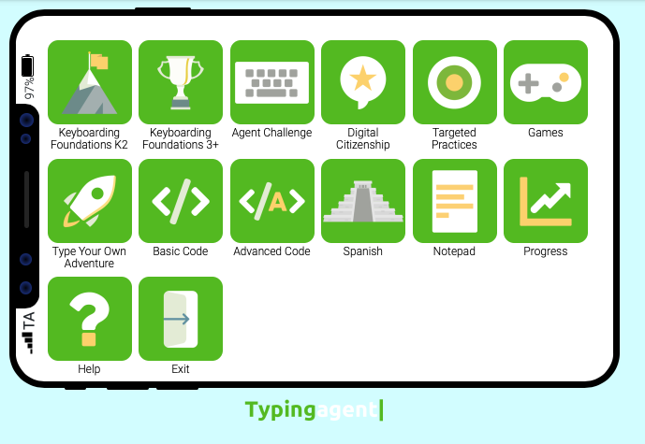

Table of Contents
How to get students interested in learning to type well 1
Scope and Sequence 2
Is there a preferred way to teach with Typing Agent and how much time do students need to attain their grade-level competencies? 3
What accuracy and speed rates should my students be attaining? 4
What is the Placement Test and why should students take it? 4
How are Diagnostic Tests used? 5
Understanding the Keyboarding Foundations K-2 Curriculum 6
Understanding the Keyboarding Foundations 3+ Curriculum 7
What do the numbers and coloring on the squares mean in the Keyboarding Foundation 3+ Curriculum mean? 9
How are lessons presented in Typing Agent? 9
What Reports are available in Typing Agent? 11
When should I make target adjustments for my students? 12
Other Curriculums in Typing Agent 13
Typing Agent Contact Information 14
Appendix A 15

This document is designed to help you understand the ins and outs of Typing Agent and use the program optimally. For deeper descriptions of concepts, ideas and operations, consult our Teacher’s Guides, Solution Center, YouTube channel or blog.

Getting students interested in learning to type well

There are no shortcuts when it comes to learning to type, so it’s the job of teachers to be the students’ cheerleader. Teachers should walk around, encourage students to use correct posture and techniques always, and push them to not give up even when they think they can’t do it. With concentrated and frequent practice, typing will get easier because they will begin using all 10 fingers correctly and stop looking down at the keyboard.

When students type 25 characters in a row correctly, a heart appears accompanied by a celebratory chime. The sound and symbol encourage students to keep typing accurately.

Though learning to type can be fun, it’s not playtime: Remind students that they need to focus and give their best at all times when using Typing Agent. Before they begin the program, discuss with them what Words Per Minute (WPM) and Accuracy goals are and why they are important. Liken it to a game where they’re trying to attain the targets set for them each and every time they enter the program. Get them excited about this. They can do it! When they have vested interest, they tend to stay engaged even when it’s tough. (If you ever doubt this, think of how relentlessly they try to pass difficult video game levels.)

Once every two or three weeks, have students use the Notepad app in Typing Agent or keep a journal to record whether they are reaching their targets and how they are feeling as they work to attain them. The simple act of:
1. Sensing their feelings as they type;
2. critically assessing their progress; and
3. Recording their impressions in some form
goes a long way in fostering greater keyboarding success. Use the students’ feedback to determine whether adjustments or accommodations of targeted goals for individual students need to be made. Click here for more information on making adjustments.

Typing Agent uses gamified lessons because students like being rewarded for a job well done. (We discuss the gamified parts later in this guide.) To keep students engaged, you could, for example, print personalized “Great Improvement” certificates for students who are giving of their best, or create a “Wall of Stars” to encourage them to earn 3 stars for each Typing Agent lesson they do (linked with Typing Agent’s Experience Points). The more stars they earn, the faster other gamified “apps” appear in their interface so they may continue practicing keyboarding in other ways while learning new skills!

We know that some people use tablets and iPads when learning to type. With Typing Agent, an external keyboard is required because typing on a glass screen is difficult due to the lack of tactile references. With an external keyboard, the bumps on the f and j keys help students keep their fingers on the home row. Also, using tablet screens often results in improper ergonomics because students tend to bend over to look at the screen.

Scope and Sequence

Students improve at different rates so some will work above, at, or below our default targets. Typing Agent’s adaptive technology meets them where they are, and provides different individualized instructional paths of learning. The table below shows the grade-level markers for when concepts are introduced, taught, and reinforced. As students are promoted through the different grades, appropriate challenges are provided. The higher the grade level, the more demanding the texts, which require higher Words Per Minute (WPM) and accuracy targets to succeed.

Typing Agent Scope and Sequence
 | K | 1st | 2nd | 3rd | 4th-12th
Pre-Keyboarding
- Offline Activities (Printed) | √ | √ | √ | √
- Mouse Work | √ | √ | √
- Posture | √ | √ | √ | √ | √
Keyboarding Skills Checklist
- Show proper ergonomics when typing or preparing to type | √ | √ | √ | √ | √
- Identify the right and left halves of the keyboard | √ | √ | √ | √ | √
- Locate the home row | √ | √ | √ | √ | √
- Demonstrate correct home row fingers positioning |  |  | √ | √ | √
- Use fingers on right and left hands to press keys | √ | √ | √ | √ | √
- Identify keys pressed correctly with the right and left hands |  |  | √ | √ | √
- Hold shift key down with “pinkie” fingers |  |  |  | √ | √
- Differentiate between the Caps Lock and Shift keys |  |  |  | √ | √
- Use one space between words |  |  |  | √ | √
- Use one space between period |  |  |  | √ | √
Keyboarding Acquisition
- Home Row Keys | Mountain 1 | Mountain 1 | Mountain 1 | World 1 | World 1
- Top Row Keys | Mountain 1 | Mountain 1 | Mountain 1 | World 2 | World 2
- Bottom Row Keys | Mountain 1 | Mountain 1 | Mountain 1 | World 3 | World 3
- Sentence and Punctuation | Mountain 2 | Mountain 2 | Mountain 2 | Worlds 4-6 | Worlds  4-6
- Numbers and Symbols | Mountain 2 | Mountain 2 | Mountain 2 | Worlds 7-9 | Worlds  7-9
- Practice to Build Speed | Mountain 3 | Mountain 3 | Mountain 3 | Worlds 10-11 | Worlds 10-11
- Maintain grade-level goals  (Spy Keyboard) | Mountain 3 | Mountain 3 | Mountain 3 | Worlds 12-31 | Worlds 12-31

For students in Grades K-2, though Typing Agent models proper finger placement in their keyboarding lessons, our main focus is to familiarize the youngsters with the keyboard by helping them understand:
- the keys never move;
- each hand has a role to play; and
- multiple fingers should be used on each hand.

Without them knowing, their body is registering how certain keys should be typed. Don’t be overly critical. Instead, insist that they use both hands and at least two fingers of each hand to type the keys. The proper use of all fingers will be stressed starting at third grade.

Ways and timeframes needed to attain grade-level competencies

Keyboarding is a body-kinesthetic skill that requires time and practice to improve. Research shows that it is more advantageous for keyboarding lessons to be short, therefore our lessons are designed to be no more than two minutes long.

Should you not have computers or tablets with external keyboards at your disposal, or you don’t want your students to begin using them immediately, don’t worry; Typing Agent provides you with offline activities for introductory and practice purposes. (Appendix A – Pre-keyboarding lesson suggestions.) Just as some piano students use cutouts to practice, your typing students may use paper keyboards to advance their keyboarding skills. Additionally, teachers or parents can make this an arts and crafts project so this adds to the fun of practicing at home or at school. (Click Offline Activities to access these resources.)

Keyboarding instruction requirements will differ between districts and schools. Due to the possibility of using the program at home, school, or both, some people use Typing Agent as a yearlong program while others use it for one or two semesters only, each year. There is no right amount of time required, but students will need sufficient time to practice to make sure their keyboarding skills improve.

Students should practice at least 10 minutes, 5 days a week – at home or at school. The program is flexible, so it may be used for whole-class instruction, center time, independent study, any combination of these, or as a bell-ringer activity. Choose what works best for you and your students.

Typing Agent has set appropriate targets and goals for each grade level. We focus on accuracy first and then speed (measured in Words Per Minute or WPM). Below is our timing chart to help you determine how much time you’ll need for keyboarding instruction. For K-2 or special needs students, teachers may want to make adjustments to better accommodate their students’ individual abilities. Our general guidelines for time needed are:

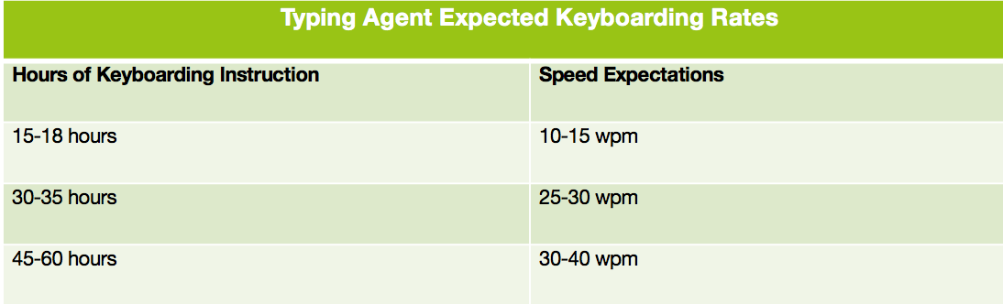

Suggested accuracy and speed rates

Typing Agent uses five WPM times (x) the student’s grade level at 85% accuracy to determine the grade-level targets toward which students work. For example, fourth grade students work toward 4 (grade level) x 5 WPM = 20 WPM and 85% accuracy; seventh graders work toward 7 (grade level) x 5 WPM = 35 WPM and 85% accuracy; etc. (Click Target Settings for more information.) Our default settings are automatically programmed to ensure students work to their specific grade-level targets:
- When students work at grade level, they earn 2 stars.
- When they work above what is required, they get 3 stars.
- When they’re a little below, they earn one star for encouragement.

Because you know your students more than we do, you could adjust these targets to best meet your students’ needs.

Furthermore, under Target Settings, Typing Agent flags when and how students work below, at, or above grade-level expectations. In our activities, we recommend that students work toward the 2-star targets at No Max Retries. When they meet these default targets, it means they are working at grade-level expectations. Our reports are always based on 2-star settings. Should you make adjustments to these settings, center everything around your 2-star changes; that is, make the 3-star targets more difficult and the 1-star targets, easier. Again, base your changes on students having to attain your new 2-star targets before moving on to the next lesson. This will ensure they are ready for the final evaluation based on your new targets.

The Placement Test students in grades 3 and above should take

Gone are the days when one size fits all for keyboarding instruction. Typing Agent has introduced assessments that allow the program to adapt to each student’s needs. Students who have never typed before are able to work alongside those who have been typing for years, due to Typing Agent’s four different paths (Paths A to D), which keeps students challenged and engaged, no matter their level. This takes a huge load off the shoulders of teachers.

Our algorithm is designed to allow students to work at their instructional level. By default, students using the Keyboarding Foundations 3+ Curriculum take a Placement Test and are then assigned the learning activities appropriate for their level. In other words, based on how well they do in that test, students are placed on a path of learning that falls anywhere between Path A (designed for students who need to begin with home-row keys) and Path D (for those who are proficient typists).

The Placement Test takes three minutes to do, maximum. It moves systematically through home-row, top row, bottom row, words, sentences and paragraphs exercises. When students make lots of errors, the test stops, identifies the path where they made the majority of errors, then places them on that particular path of learning. There is no other way outside of the Placement Test that students may be placed on a path. Should it be determined that students do not type at an appropriate accuracy and speed for their grade level from the outset of the test, the program places students on Path A.

Should teachers or administrators want students to skip the Placement Test to begin with the home-row keys immediately, they can override the default settings. For instructions on how to do this, click on your role to be taken to instructions on how to disable this: Teacher, School Administrator, or District Administrator.

How to use Diagnostic Tests

Baseline tests allow administrators and teachers to determine what students know before instruction begins and then that same can test to ascertain how much students have learned during and after instruction is completed. Typing Agent adopts the same approach with our Diagnostic Tests. Before students begin their keyboarding lessons, all of them, even those in kindergarten, take this baseline/Diagnostic Test. As students complete their keyboarding lessons, the same test appears at various times during the program to track progress or improvement over time.

For students using the Keyboarding Foundations K-2 Curriculum, Diagnostic Test 1 is one minute long. The test is designed to stop after either one minute is up or when students type a letter incorrectly five times consecutively – whichever happens first.

The test shows one letter at a time on the screen and students type that letter. Should the students get the letter correct, the next letter appears. Whenever they get a letter incorrect five times in a row, the test stops immediately and the students move on to their assigned keyboarding curriculum.

For students in Grades three and above, the Diagnostic Tests follow a different format. Students instead get two minutes to type. Should they type a letter incorrectly, they can’t move forward until they correct the error. Once they’ve completed the test, they get feedback on how well they did and are then taken to the Keyboarding Foundations 3+ Curriculum.

Results for these tests are found in the Reports section. For the Placement Tests, we show in which path students were placed. For the Diagnostic Tests, we detail the accuracy, speed and grade earned in that and all subsequent Diagnostic Tests.

In total, K-2 students get four Diagnostic Tests, which are given before each new mountain to climb. Grades 3+ students get 28 Diagnostic Tests, one after completing World 3 and subsequent lesson units in their Worlds.

The Keyboarding Foundations K-2 Curriculum

When students log into the Keyboarding Foundations K-2 Curriculum, their interface looks like this:

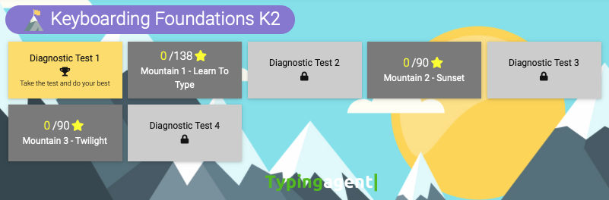

Notice the yellow rectangle with Diagnostic Test 1: this is where students begin. All of the other Diagnostic Tests are light grey. As students climb the mountain, when a test is ready to be taken by students, it will always be in yellow. Once the test is taken, that box turns green and results will appear in the WPM and ACC areas. Remember these are your benchmarks to show improvement over time. Mountains 1, 2 and 3 are in dark grey. As students climb each mountain, the mountain they’re working on turns light blue and the star count will change. Notice that on Mountain 1 – Learn to Type there are 0/138 stars. Should students earn 3 stars in all of their Main Activities, they will earn 138 stars when they’ve completed that first mountain’s lessons. Remember, we want them to earn 2 stars per lesson, so if they earn 3, they are really doing well.

Mountain 1 has 15 flags. Under each flag there are practice and main activities. The Learn to Type area uses gamified activities to get students practicing new keystrokes not learned as yet. These animated adventures motivate students while their fingers get used to hitting the new keys. Once they’ve practiced enough, students move on to Main Activities. The Main Activities area is for assessment purposes so if your students feel they want to practice more, they may always go back and redo those Learn to Type activities. You may use the results from the Main Activities as formative assessments.

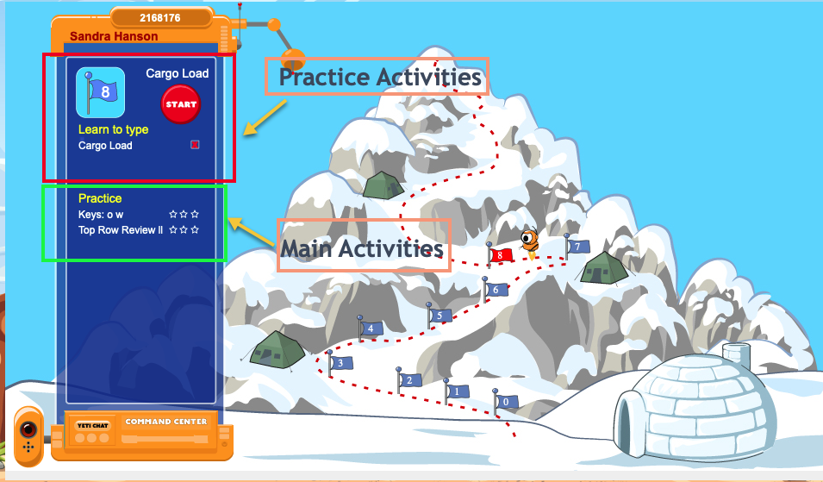

Once students have finished Mountain 1, Diagnostic Test 2 will turn to yellow, indicating that may now go and do that test. Once it’s completed, results appear in that rectangle and Mountain 2 will turn light blue, signaling that it’s now ready to be climbed.

Mountains 2 and 3 feature new and old keystrokes. When new keys are introduced, the program teaches how to type those keys then have students practice them before moving on to the main activities, where they are graded. The keyboard remains at the bottom of their screens so that should they need help remembering how to type the keys, they may always look at what the hands at the bottom of the screen are doing. Mountain 2 has 30 flags where students focus on capitalization and punctuation marks. Mountain 3 has 30 flags where students focus on numerals and special characters. Because by this time, students will have been introduced to all the keys on the keyboard, the Learn To Type lessons are shortened.

The Keyboarding Foundations 3+ Curriculum

This curriculum is different from the one given to K-2 students. Even though the interface may look the same, the Keyboarding Foundations 3+ Curriculum uses different content for students in Grades 3, 4-5, 6-8 (middle school) and 9-12 (high school) to get students to reach their specific grade-level goals. This curriculum uses Worlds for instruction. Each World has 10 lessons represented by the circles seen at the top of the image below. When the student selects a World, the lesson they are working on appears as a blackened circle. Every lesson has a varying number of activities but each with its own Main Activity, as illustrated below.

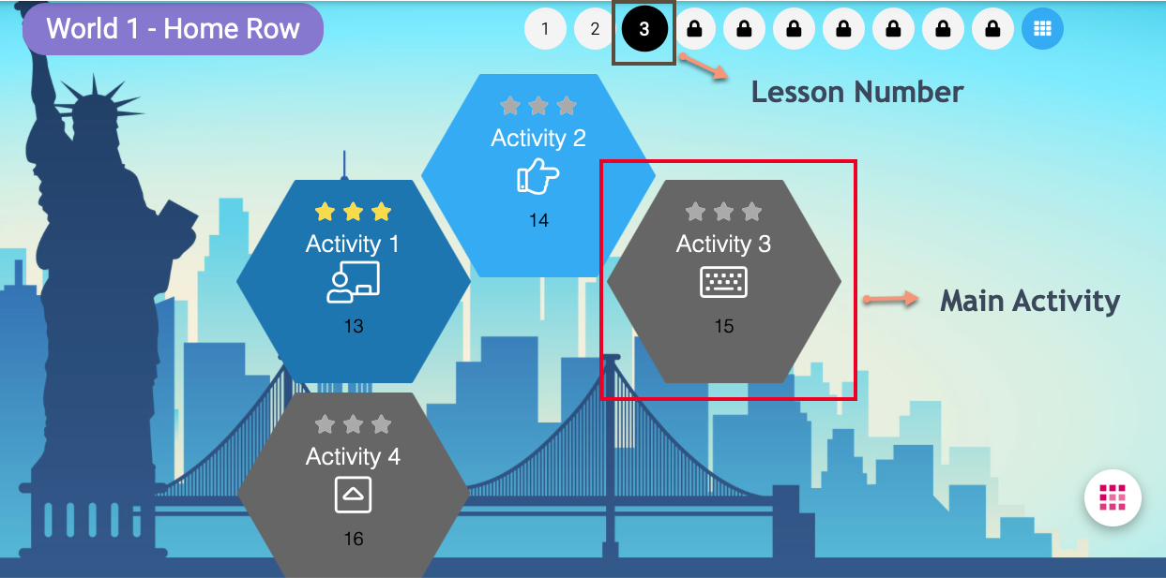

When students see a Main Activity icon (the keyboard icon highlighted in the image above inside the red box), it means that these activities are graded. Teachers may use the results of these activities for the purposes of formative assessments. As shown above, World 1 – Home Row, has 10 lessons (represented by circles at the top). Lesson 3 (blackened circle) has 1 Main Activity. In Worlds 1-3, each lesson has one Main Activity that is graded. From Worlds 4 and up, all activities are considered Main Activities and are graded as such. At this time, students will have learned all the letters on the keyboard and are now being required to maintain those skills already learned. When new keys such as numerals and symbols are introduced, students get practice lessons before the Main Activity is given and graded.

Worlds 1 through 3 use gamified activities so students can get lots of practice when learning new keys. We encourage students to go slowly in order to build muscle memory as they learn to find new keys without looking down at the keyboard. As they continue going through the lessons, only the ones where new keystrokes are introduced, are gamified.

Upon completion of the Main Activity, a customized Type Up lesson appears so that students get to have more practice and opportunities to improve the keystrokes that gave them the most trouble. The following icons indicate the lessons/activities available within Typing Agent:

Video New Keys Instruction
Star Destroyer Game
Anchor Left Anchor Right
Main Activity (Graded) Type Up: Adaptive

What the numbers and coloring on the squares mean in the Keyboarding Foundation 3+ Curriculum

The illustration below shows the area where students and teachers can get a lot of information at a glance. Diagnostic Test boxes turn green when they are completed. If the box is red or yellow, it means that test has not been taken yet. When a World box is dark blue, it means that all of its lessons have been completed. A light blue World box means that the student is still working in that area. Whenever a World or Diagnostic Test box is grey, it means that these areas are locked and cannot be accessed until the required previous steps have been completed successfully. By clicking on the light blue box, students are taken immediately to where they left off.

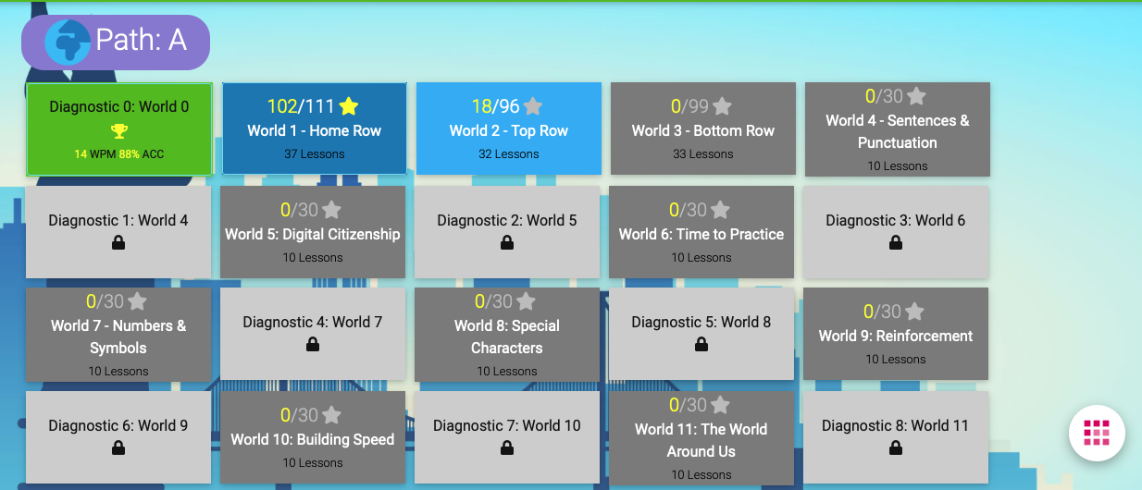

The presentation of lessons in Typing Agent

Typing Agent is often referred to as a time-based curriculum. Whether students are using the Keyboarding Foundations K-2 or the Keyboarding Foundations 3+ Curriculum, each activity is short and sweet, lasting 1 to 2 minutes, maximum. This is so that students remain focused as they type their lessons. After doing an activity, students should take a little break (a few seconds), then, depending on how they did, repeat or move on to the next activity. Because students focus on typing the texts accurately, muscle memory and speed build simultaneously. With this in mind, students will need to pay full, careful attention while using Typing Agent. While it may be a lot of fun, their keyboard skills won’t develop as quickly and proficiently if they’re only using it to play or as entertainment only.

When K-2 students log into their keyboarding workspace, they will see an icon like the one below, which tells them the Mountain they are in:

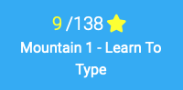

Those in grades 3 and higher see an image like the one below, which tells them the World they are in:

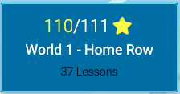

Remember the goal is always to attain 2 or more stars for every lesson.

The numbers help motivate students to do their best to collect all the stars available in each Mountain or World. The first number indicates how many stars a student has earned so far in their lessons while the second number tells how many stars are available in that Mountain or World. Before students begin an activity, they are shown the Benchmark Challenge, which tells them exactly the accuracy and WPM they need to get in order to earn 1, 2, or 3 stars. When they finish an activity, students get immediate feedback telling them how they did and the number of stars earned. If they did not earn 2 or 3 stars, students will have to redo that lesson immediately, if they are working toward our grade-level targets.

If you are satisfied with students working toward only 1 star, students may redo those lessons at a more convenient time to earn higher scores. All students have a Progress icon on their screens.

When students click on this icon, they get a thumbnail of each curriculum that contains the current results. Clicking on any of them shows more detailed information. For their keyboarding curriculum, they may click on any lesson with 0 or 1 star and redo them. This will give them extra practice to eventually learn to type the keys effortlessly.

Reports available in Typing Agent

There are many useful reports available! Click Reporting (District Administrators) or Reports (Teachers and School Administrators) to access a plethora of data available to you. Before school opens, we advise that you go through each one to see which appeal to your praxis. We don’t assume that all teachers want or will use the same reports the same way so by having many, you get to choose which ones work best for you!

When District Administrators click the Reporting button, they see a graph and boxes that provide a global look at how students are doing with their keyboarding lessons. At the bottom of that page, they can select different reports providing school-, classroom-, teacher- or student-based information. (Click here for more information on reports for District Administrators.)

School Administrators click on their Reports button at the top of their splash page and can get school- or class-based reports. They also have access to the same reports available to classroom teachers by simply clicking on a classroom listed on the left. Whereas School Administrators see everything for their school, teachers see the data for their classrooms only. Once teachers click on a classroom, they get a Reports page that looks like this:

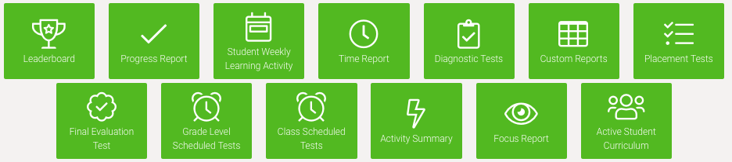

Our educators have indicated these to be their favorite reports: Progress, Student Weekly Learning Activity, Time, and Custom. (Don’t confuse the Student Weekly Learning Activity and Time reports; they look similar but provide different information.) Just because some reports are used most frequently does not mean the others are without value. Depending on your needs, you may find the others are just as informative. For example, if you want to know how students did on a specific lesson, then use the Focus report and should you want to know what students are doing right now, then the Activity Summary report is where to look. (Click here for more information on reports available to teachers.)

When to make target adjustments for students

About two to three weeks after students have begun Typing Agent, review the Summary part of the Progress Report to see how well your students in a particular class are doing. The report will look something like this (a legend appears at the top to spell out what the icons mean):

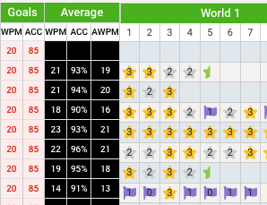

If the report shows results like this, you’ll see right away that this classroom or some students in it are not working toward our default settings, because if they were, no student will have 1 or 0 flags more than once. They will have to improve those lessons before moving on. (Administrators have the ability to update our default settings to give teachers the ability of updating their students’ settings. This means that the teacher will have to monitor students’ success more closely instead of our algorithm doing so.)

The Goals columns show what WPM and Accuracy goals students are trying to achieve by the end of this year’s course. At a glance, this informs teachers if there are students working toward modified goals. It is not recommended that the 2-star accuracy goal is lowered under 85% accuracy for students in Grades 2 and above; accuracy is more important than speed. You may use your discretion for the younger ones.

The Average columns allow you to identify if there are any students working above or below the 2-star average. Should you see students consistently earning 3 stars, this indicates that their targets are set too low for their level and they are thus not being challenged; you’ll want to reset these. Conversely, if they are getting 1 star or flags, their targets will also need to be adjusted to something they can better manage. (Check out this help file should you need further assistance with adjusting targets.)

Before making any changes to targets, we suggest that you:
- have a chat with the student(s) to see what’s going on.
- adjust the WPM target settings – 5WPM in either direction for the 1-, 2-, and 3-star targets. (Remember, the goal is to type accurately so do not adjust the Accuracy Target Settings.)

Whether or not you’ve made adjustments for your students, about a month later, check to make sure they are progressing adequately. If needed, make further modifications. (The Progress Report tells you where your students are at and how they’re doing.)

Because many students are learning from home, it is important to advise parents that only the student should be working in their Typing Agent account; no one but the student should be doing the exercises because this undermines the integrity of the curriculum and skews results for all. (This seemingly harmless “helping” will negatively affect data collected for that student, class, school and district.) If the child is struggling or complaining, parents should encourage them to continue trying. If the student is still struggling, parents should contact the teacher for target adjustments. Parents should never do the work for the child because ultimately, they are not helping.

Supplementary curriculums in Typing Agent

Most teachers don’t notice that there are complementary curriculums available to them: These additional curriculums support the further development of keyboarding skills in the program. By default, these curriculums become available when students have completed sufficient work in their Keyboarding Foundations Curriculums. Typing Agent’s default settings open these up at appropriate moments depending on the number of Experience Points acquired. For example, our gamified lessons make learning to type engaging and fun. As such, our Games arcade becomes available to students only after they’ve learned to type all of the letters – approximately after Mountain 1 for K-2 students and after World 3 for Grades 3 and above.

Should teachers bypass our default settings and make the games available from the start, students will likely develop bad habits. With the games, they will be turning their attention toward “winning” instead of adopting proper the typing techniques and WPM required for their new grade level.

Should you want students to access these supplementary curriculums earlier, or later, than our defaults, simply adjust settings to give students access. Should your students finish their year’s keyboarding curriculum early, there is always something else to do within Typing Agent. It’s just a matter of taking advantage of all of the curriculums and features available to you. (Click here for more information on our other curriculums.)

Conclusion

Typing Agent will help your students learn to type and use technology with proficiency. If you have not made any adjustments to our default settings, all teachers and administrators have to do is check reports from time to time to make sure students are working up to par and keep cheering them on. If you have made modifications, please pay closer attention to them as they type and keep an eye on the reports to make sure your students are working well.

Typing Agent Contact Information

If you ever need any help, visit the Solution Center, where you’ll probably find answers to commonly asked questions. A quick keyword search will help you find easy, step-by-step instructions with videos. Should you want to do a search related to your role only (District Admin, School Admin, Teacher, or Standalone School Admin), just add that to your search and the guides specifically associated to your post will be shown first. Visit https://help.typingagent.com/en to get to this area.

You may also contact Typing Agent by:
- In-app chat (blue box at the bottom right when you log in);
- Email us at support@typingagent.com; or
- Call us at (425) 880-2500.

Appendix A – Pre-keyboarding lesson suggestions

These are warm-up activities to get students ready to use real keyboards. (Additional activities are in the Activities Booklets area in each classroom.) When students are learning new keystrokes online, you may modify these activities to new skill acquisition.

1. Finger Play

Objective: Students warm up their fingers, develop their manual dexterity, identify left and right hands, and name their different fingers on each hand.

Materials needed: None

Activity: Have students close their eyes and touch the corresponding finger on each hand, i.e. touch pinky with pinky, ring finger with ring finger, etc. Then increase difficulty by having them touch thumb on right hand with ring of left hand, or ring on left hand with middle of right hand, etc. Do different combinations, stressing the difference between the left and right hands.

Modification: Have students clap then stop upon your instructions. Then have them raise their hands in a palm-to-palm position, but with fingers curved, like they’re holding a ball, and ask them to touch their fingertips according to your instructions, i.e. pinky to pinky, right-hand pinky to left-hand ringer finger, etc. Try different combinations. Again, continue having them focus on the left and right hands and using the correct finger called while keeping fingers curved.

2. My Practice Keyboard

Objective: Students learn key placement by making their own practice keyboards.

Materials needed: Sticky (or blue) tack or adhesive Velcro, scissors, bag or container, photocopies on paper or cardboard of a blank keyboard, paper copies of letters/characters placed in squares that look like keyboarding keys. (Keyboard Cut Out Activity stencils are found under the three horizontal dots on the right in each classroom.)

Activity: Supply the kids with the materials, and explain that they will be making their own practice keyboard. Model the activity by showing your empty keyboard, a real keyboard and proceed to do a Talk Aloud demonstrating the steps, i.e. it looks like the letter J is near the middle of the home row and affix your letter J to the appropriate key on your empty keyboard. Use the language of keyboarding to familiarize your students with the terms they’ll need. Once they understand the concept of replicating a keyboard on their blank version, have them proceed to construct their own. This exercise can be repeated as desired.

3. Colorful Fingers

Objective: To have students connect each finger with a color that corresponds to proper positioning on a keyboard for accessing specific keys.

Materials needed: Typing Agent’s finger-placement poster, the practice keyboard your students have made or Individual printouts of keyboard, crayons or colored pencils.

Activity: Review the names of individual fingers; i.e., ring, index, pinky, middle and thumb. Refer to the Typing Agent poster and discuss the different colors and how they correspond to these different fingers, i.e. ask students to refer to the chart and identify which hand/finger should type the letter R; go through several keys until you feel the students understand. Have students copy the colored groups onto their own practice keyboards, color by color, reminding them of the fingers to which they correspond. Walk around to make sure students are doing this correctly. Continually stress that they will need to use all ten fingers to become the best typist possible. You could demonstrate this.

4. Rainbow Fingers

Objective: To have students connect each finger with a color that corresponds to proper positioning on a keyboard for accessing specific keys.

Materials needed: Stock board, crayons/colored pencils, pencil/pen, Typing Agent’s keyboard poster.

Activity: Have students trace outline of their hands, then color the outline of each finger with the corresponding Typing Agent color. As they learn each letter, they write it on the correct finger to use to type it.

5. The Keyboard Hopscotch

Objective: To have students visualize position of letters/characters on the keyboard by locating the right spot to stand in.

Materials needed: Chalk and Typing Agent keyboard poster.

Activity: Before class, use chalk to draw squares on the ground forming a giant keyboard; older students could be asked to configure this. Give students large cut-outs of different letters/characters. Call one letter at a time, and the child with that letter will go stand on the correct spot. Ask the student if s/he is sure about being on the right spot or if s/he needs help; then ask the remaining students the same question of the student who has just taken a spot (the student could ask for help if s/he is overly sensitive). Do not correct students standing in the wrong spot and left there uncorrected by the class; as the game evolves, the problem will be identified and remedied collaboratively as a group. (Game could be limited to solely letters learned, and as students move through the program, the letters they learn could be added to the activity. Just do multiple rounds if you have more students than letters learned.)

Modification: In lieu of calling out single letters/characters, instruct students to correctly fill in the home row, top row, etc.

6. Every key has its place

Objective: To have students be able to construct their own keyboard by visualizing the position of letters/characters and filling in blank spots.

Materials needed: Cut-outs representing each key on a keyboard and the Typing Agent keyboard poster.

Activity: Have each student find a spot with their key cut-outs. As a group, consult the Typing Agent poster to identify the keys in a row, for example, the home row. Cover the poster and ask students which letters are in the home row. Once the students have identified those letters, have them find and lay them down in front of them in the correct order. Have students review each other’s home row to make sure they are correct. Repeat this sequence with another row until the students are able to construct entire rows.

Modification: Once students can reconstruct rows, have them reconstruct the whole keyboard by calling out keys randomly.

7. Anchors away!

Objective: To have students recognize the F and J tactile reference points (anchors).

Materials needed: Individual printouts of keyboard, drops of glue (need to dry as a bump).

Activity: Before giving students printouts of the keyboard, put a dollop of glue on the F and J keys. Have students find the letter F on the keyboard, touch it with their left index finger and describe what they feel on that key that is different from other keys. Then have them type D, S and A with their middle, ring and pinky fingers, respectively. Now ask students if they can find another key that feels the same as F, with its tactile reference. When they identify the key for J, have them touch it with their right index finger. Then ask them to touch the letters K, L, and semi-colon with their middle, ring and pinky fingers, respectively. Reinforce how the tactile references of F and J are found on all keyboards and will always serve to help them find the home row without having to look. Then have them wiggle their fingers above their heads with eyes closed, and find the letters F and J using only their sense of touch; they must keep their eyes closed. With their eyes still closed, ask them if they are sure their index fingers only are on F and J, and if so, let their other fingers fall into position, including their thumbs over the space bar. Have them open their eyes to check and see if their fingers are correctly positioned on the home row.

When students can find the home row through touch only, have them bang the home row keys hard; then have them strike the keys lightly, only being aware of where the tactile references are found. Guide them to understanding that now that they know how these tactile references help them anchor their correct finger position on a keyboard, there’s no need to bang the keys; light taps get the job done better. Build on this understanding by having students find other letters as they learn them in typing. The key thing is getting them to find the F and J keys, relax their fingers curled over the keys and branch out from this anchored position with their eyes closed or without looking at the keyboard. Practicing this consistently before students start working with a real keyboard will keep them from “cheating” by looking for the keys.

8. Stand tall, sit smartly

Objective: To have students adopt comfortable and ergonomically sound postures when keyboarding.

Materials needed: Typing Agent’s Ergonomics Poster.

Activity: Review the poster with students and discuss the importance of each correct position it describes. Then have students model and correct incorrect positions, i.e. one student may choose to sit in a slouched-shoulder position, and the other students will need to identify what that student is doing wrong and what s/he needs to do to correct it. Remind students that bad habits may be difficult to correct, and they will need to do their best to not develop them.

9. Keyboard Bingo

Objective: To reinforce students’ understanding of placement of keys on a keyboard.

Materials needed: For student: blank keyboards and cut-outs of individual keyboard letters/characters / For leader: A container with cut-outs of individual keyboard letters/characters.

Activity: Leader calls out a letter/character and students place their cut-outs on the corresponding key. The first student to complete a row will call out Keyboard bingo! The leader will verify that the cut-outs have been placed correctly on the blank keyboard.

